
Project Documentation
Data Center / Disaster Recovery

October 23, 2026
BY: Ritesh Chaudhary

Table of Contents
1. Abstract 2
2. Purpose 2
3. Scope 2
4. Objectives 2
5. Introduction DC/DR 2
Data Center (DC) 2
Disaster Recovery (DR) 3
6. Importance of Data Center Disaster Recovery 3
7. Risk Assessment & Business Impact Analysis (BIA) 4
8. Recovery Strategy: 5
8.1 Backup & Restoration Strategy 5
8.2 High Availability & Failover Measures 6
9. Recovery Procedures 6
9.1 Emergency Response Workflow 6
9.2 Server & Application Recovery 7
9.3 Network Recovery 8
10. Disaster Recovery Team 8
11. Testing & Maintenance of the DR Plan 8
11.1 Testing & Simulation Exercises 8
11.2 Maintenance & Continuous Improvement 9
12. Alternative Data Center Disaster Recovery Sites 9

1. Abstract
This Data Center and Disaster Recovery Plan (DC/DR Plan) provide a comprehensive framework to ensure continuous availability, protection, and recoverability of the organization’s IT infrastructure and business-critical systems. It establishes standard procedures for responding to natural disasters, cyber incidents, system failures, and other disruptive events affecting the data center.

2. Purpose
The purpose of this document is to outline standards and procedures required to maintain operational continuity, protect digital assets, ensure data resilience, and enable fast recovery of IT services during any unexpected event. The plan ensures the organization can restore operations with minimal downtime and data loss.

3. Scope
This plan applies to:
- All on-premises and cloud data centers
- Servers, databases, storage, and network infrastructure
- Critical applications, middleware, and services
- Physical and cybersecurity controls
- All IT, databases, and network operations staff

4. Objectives
The key objectives include:
- Ensure 24/7 availability of mission-critical systems
- Protect data from loss, corruption, and unauthorized access
- Minimize downtime during disasters or outages
- Enable structured recovery within defined RPO (Recovery Point Objective)/RTO (Recovery Time Objective)
- Support continuous business operations

5. Introduction DC/DR

Data Center (DC)
The primary Data Center operates as the main production environment equipped with high-availability architecture, redundant power, precision cooling, fire suppression, biometric access control, and resilient network infrastructure. It hosts all mission-critical computing, storage, and network systems.
The below diagram helps visualize how servers, storage, network devices, power and cooling are arranged — a useful reference for both technical and non-technical stakeholders.
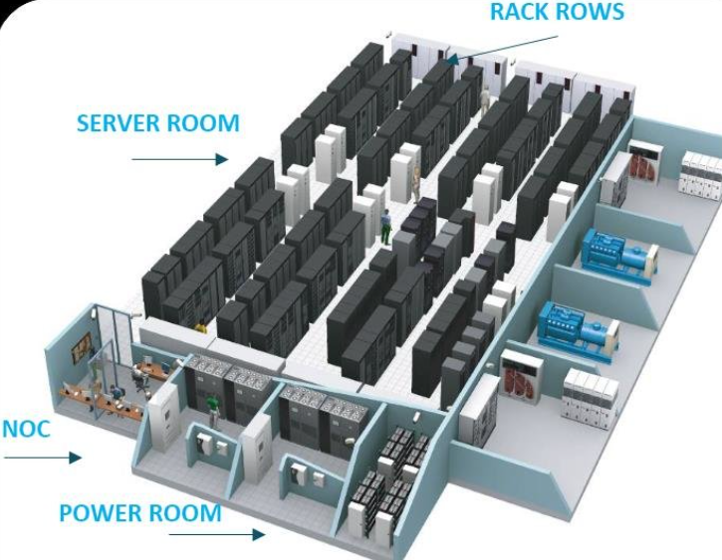 | 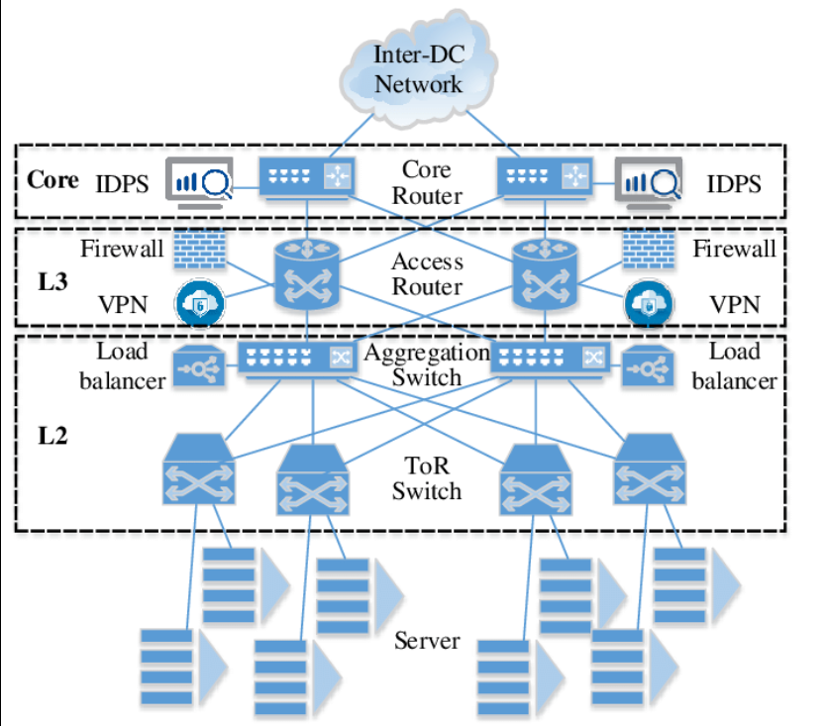 | 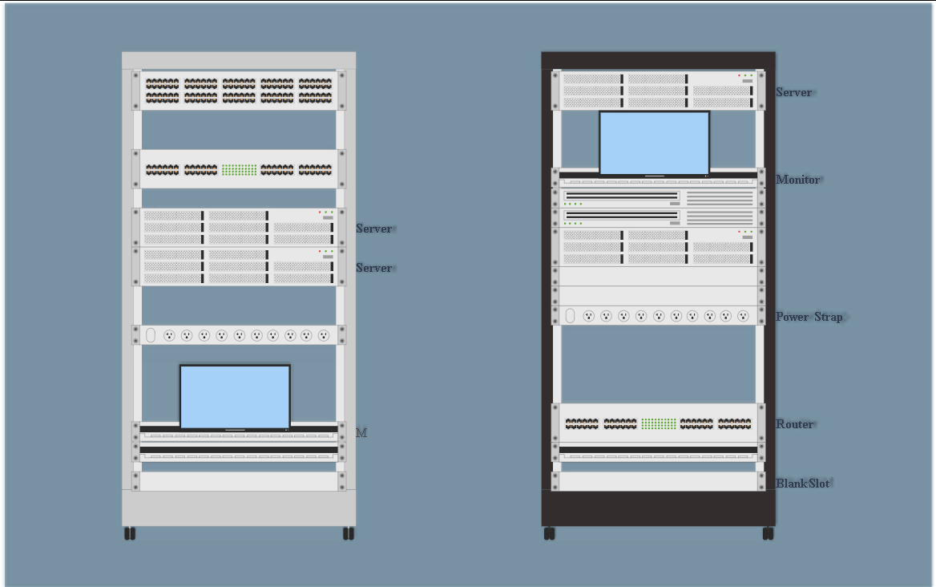
Fig 1: Typical Data Center Layout & Architecture

Disaster Recovery (DR)
The Disaster Recovery site is a secondary facility geographically separated from the DC. It maintains synchronized replicas of production systems to ensure service continuity. DR may be a physical site, cloud-based DR infrastructure, or hybrid replication model.
Below images visualization clarifies how the primary data center connects with DR including replication links, failover paths, and standby infrastructure.
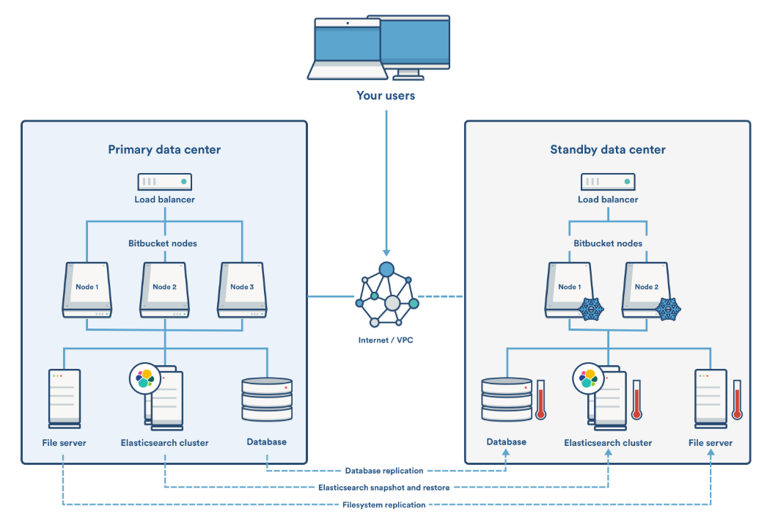 | 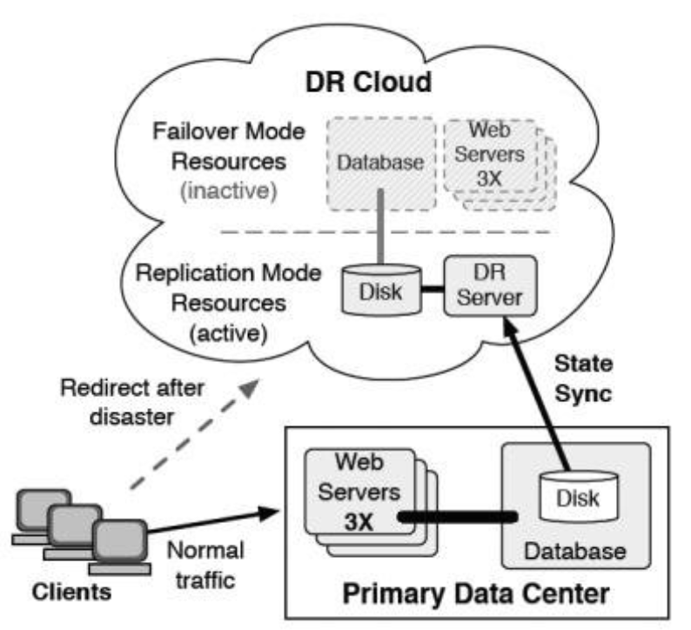 | 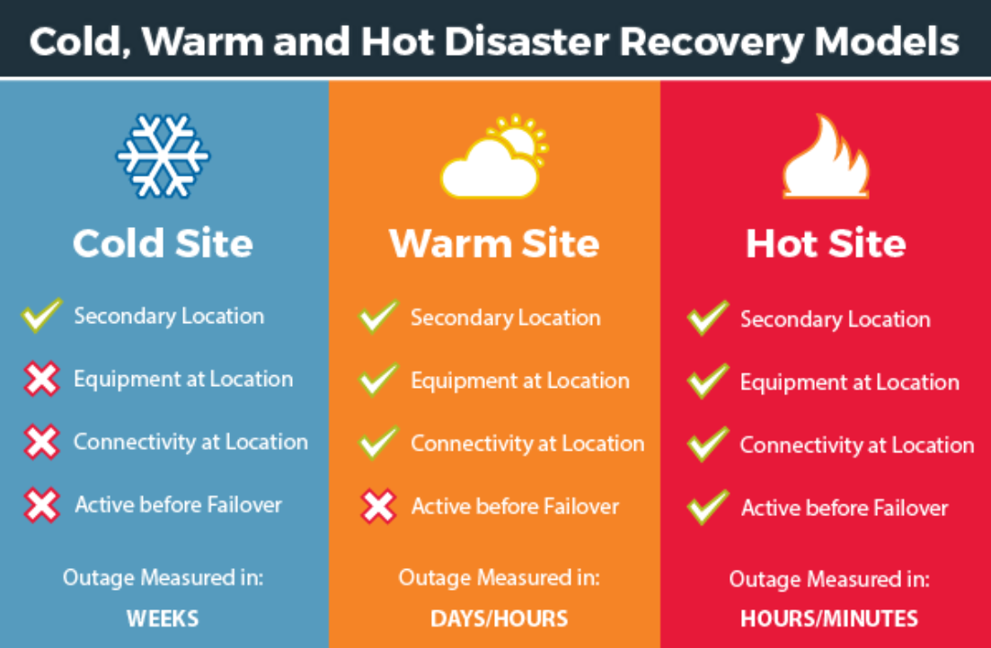
Fig 2: Data Center, DR Site Architecture & Replication Flow

6. Importance of Data Center Disaster Recovery
Data Center Disaster Recovery (DCDR) is essential for ensuring operational resilience and enabling organizations to withstand unexpected disruptions. A robust DCDR strategy safeguards critical systems, protects valuable data, and supports uninterrupted business functions. The following key factors highlight their importance:
- Business Continuity:
A comprehensive disaster recovery plan ensures that essential business operations can continue even during severe disruptions. This reduces downtime, minimizes financial impact, supports employee productivity, and preserves customer confidence. Frameworks such as ISO 22301 (Business Continuity Management Systems) provide widely adopted guidelines for establishing effective continuity controls.
- Data Protection:
Organizational data is a critical asset that must be preserved during any disaster. Effective DR measures prevent data loss, corruption, and unauthorized access, ensuring that information remains secure and recoverable to its original integrity after an incident.
- Regulatory Compliance:
Many industries are governed by strict data availability and disaster recovery requirements. Regulations such as HIPAA (healthcare) and FINRA (finance) mandate secure data management, while overarching standards like NFPA 1600 provide structured guidance for preparedness and recovery. Adhering to these standards helps organizations avoid costly legal and compliance penalties.
- Reputation Management:
Extended downtime or loss of critical data can severely damage an organization’s credibility. A well-implemented disaster recovery capability reflects reliability and commitment to service quality, helping maintain customer trust and protect the organization's brand image.
- Cost Efficiency:
Although disaster recovery implementation may involve initial investment, it significantly reduces long-term financial risk. Effective DR planning helps avoid substantial losses arising from operational downtime, data breaches, and reputational damage, resulting in overall cost savings.
7. Risk Assessment & Business Impact Analysis (BIA)
Risk assessment focuses on identifying threats that could impact the continuity and stability of data center operations. Key potential risks include:
- Hardware Failures
Example: Failures in essential components such as servers, routers, switches, or storage systems that may cause partial or complete service interruptions.
- Power Outages
Example: Long-duration power failures that affect the entire facility, resulting in system downtime and possible data integrity issues.
- Cybersecurity Threats
Example: Ransomware, malware, or unauthorized access attempts that compromise system availability, data confidentiality, and operational continuity.
- Natural Disasters
Example: Earthquakes, floods, fires, or other environmental events that damage physical infrastructure and cause extended downtime or data loss.
- Network Failures
Example: Disruptions in internal or external network connectivity due to ISP issues, faulty network devices, or configuration errors, leading to service unavailability and communication breakdowns.
- Human Error
Example: Mistakes such as accidental data deletion, misconfiguration of systems, improper patch installation, or failure to follow procedures, all of which can lead to system outages or data compromise.
Business Impact Analysis (BIA)
The BIA evaluates how disruptions affect business processes and identifies the criticality of each system. Through this assessment, organizations determine the financial, operational, and reputational impact of service interruptions. It also helps establish system recovery priorities and guides the definition of acceptable Recovery Point Objectives (RPO) and Recovery Time Objectives (RTO). By understanding how each asset supports business operations, the BIA ensures that recovery strategies are aligned with organizational needs and compliance requirements.

8. Recovery Strategy:

8.1 Backup & Restoration Strategy
A structured backup and restoration approach ensures that business-critical data and systems can be restored with minimal downtime.
Backup Plan
- Perform daily full backups and periodic incremental backups for critical databases, virtual machines, and configurations.
- Store backups in secure on-site storage and maintain off-site or cloud backups for geographic redundancy.
- Conduct regular backup integrity checks, ensuring that recovery files can be successfully restored.
Restoration Process
- Restore data from the latest validated backup in the event of data loss.
- Utilize documented configuration baselines and configuration-management tools for quick restoration of system settings.
- Perform restoration drills periodically to validate readiness and improve recovery efficiency.
Below images help clarify how data flows from production servers to backup storage to off-site/cloud to restoration to enhancing understanding for audit, operations, and compliance.
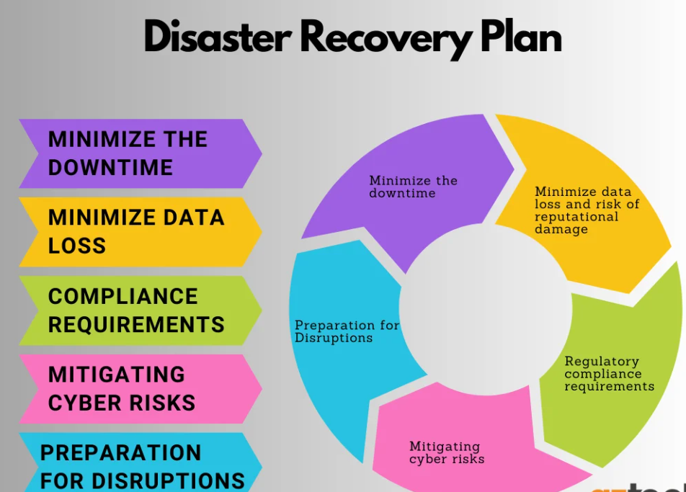 | 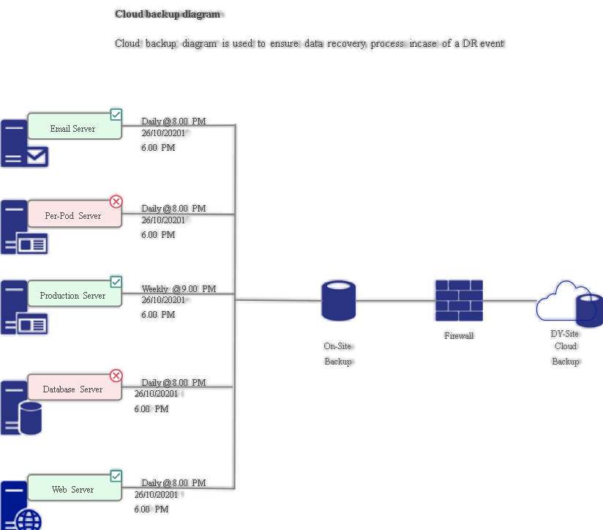 | 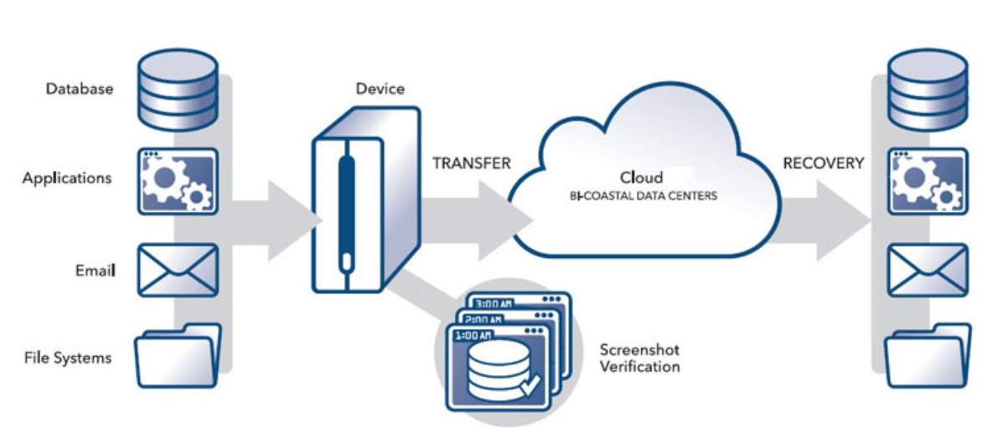
Fig 3: Backup & DR workflow illustration

8.2 High Availability & Failover Measures
To maintain continuous operations, the data center uses high-availability (HA) designs that reduce single points of failure.
Redundant Infrastructure
- Deploy redundant servers, network devices, and storage units to protect against hardware failure.
- Maintain multiple network paths and enable automatic failover to ensure uninterrupted connectivity.
Failover Configurations
- Use server clustering for critical applications and database replication for maintaining synchronized standby instances.
- Configure automatic failover mechanisms for both application and database layers to ensure minimal service disruption.
Load Balancing
- Implement load balancers to distribute traffic across multiple nodes, improving performance and resilience.
- For multi-site deployments, use Global Server Load Balancing (GSLB) to provide geographic redundancy and swift failover during regional outages.

9. Recovery Procedures

9.1 Emergency Response Workflow
This process ensures rapid and coordinated action when a disaster occurs.
Detection & Notification
- Monitoring systems alert IT teams to outages, hardware failures, or security events.
- Emergency contacts, escalation paths, and communication channels (email, messaging tools, phone) are predefined.
Initial Assessment
- Response teams assess the severity and impact on servers, network, data, and applications.
- Findings are documented and shared with leadership to determine the appropriate recovery approach.
This supports clarity and ensures all team members know what actions to take during a crisis.
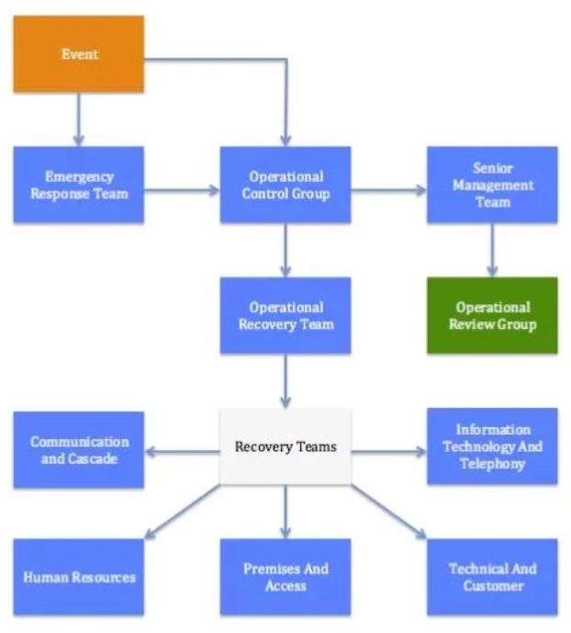 | 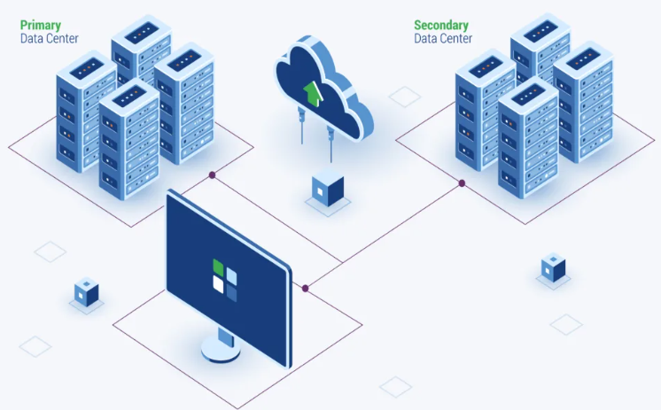 | 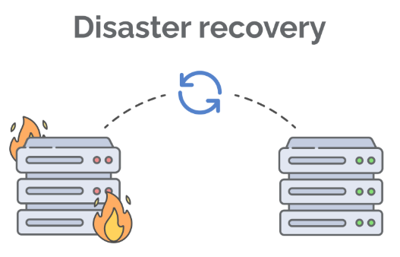
Fig 4: Emergency Response Workflow / Incident to DR Activation Flowchart

9.2 Server & Application Recovery
Recovery Process
- Prioritize restoration of Tier-1 systems (Domain Controllers, Database Servers, Application Servers).
- Restore domain controllers first to re-enable authentication and directory services.
- Recover database servers, validate data integrity, and restore dependent applications.
- Verify functionality through system testing before moving to less critical systems (file servers, web servers).
Validation & Documentation
- Validate recovered systems using predefined test cases.
- Update system documentation with final configurations and recovery notes.
- Communication system recovery status to stakeholders.

9.3 Network Recovery
Network Restoration Steps
- Restore network device configurations from backup (routers, firewalls, switches).
- Replace or repair failed hardware and re-apply configuration backups.
- Test internal and external connectivity, including routing, VLANs, firewall rules, and VPN services.
Post-Recovery Actions
- Update network topology and configuration documentation.
- Perform network-wide functional testing to ensure stability and efficiency.
- Inform relevant teams about network restoration progress and any temporary solutions.

10. Disaster Recovery Team
- Recovery Team: Establish a dedicated Disaster Recovery (DR) Team consisting of employees, contractors, and vendors. Define a clear chain of command and assign specific roles and responsibilities, including decision makers, technical leads, and communication coordinators.
- Team Training: Ensure all team members are trained on DR procedures, tools, and protocols. The team should be prepared to respond 24/7 in case of an incident.
- Contact Directory: Maintain an up-to-date and easily accessible directory containing contact information for all DR team members, including primary and backup contacts.

11. Testing & Maintenance of the DR Plan
On-going testing and maintenance ensure that disaster recovery capabilities remain effective, accurate, and aligned with changes in the IT environment.

11.1 Testing & Simulation Exercises
Regular DR testing validates the recoverability of critical systems and ensures that teams can respond effectively during an incident.
Testing Schedule
- Conduct a full DR test annually, complemented by smaller targeted tests during the year when needed.
- Plan testing within a defined maintenance window to minimize business impact and notify stakeholders beforehand.
- Use different recovery scenarios, such as system failure, cyber incident, or network outage—to evaluate preparedness across multiple threat types.
Testing Workflow
- Simulate disaster detection, verify notification processes, and activate the DR response team.
- Execute documented recovery steps with participation from IT and relevant business units.
- Validate restored applications, databases, and network connectivity to ensure they function as expected.
- Review documents during testing, capture inaccuracies, and update procedures accordingly.
- Conduct a post-test review to document lessons learned and identify improvement areas.

11.2 Maintenance & Continuous Improvement
The DR Plan must evolve along with infrastructure and business operations.
Infrastructure & Configuration Updates
- Review infrastructure changes (servers, network, storage, applications) on a regular schedule to keep the DR plan aligned with the current environment.
- Maintain configuration accuracy using automated tools or documented change tracking.
Plan Updates & Enhancements
- Integrate DR updates with the organization’s change management process to ensure modifications in production systems automatically trigger a plan review.
- Incorporate lessons from DR tests and simulations to strengthen procedures and address gaps.
Documentation & Communication
- Maintain version-controlled DR documentation, ensuring all updates include a clear change history.
- Keep consistent communication with IT, security, and business teams to ensure feedback is captured and the plan remains effective and relevant.

12. Alternative Data Center Disaster Recovery Sites
In addition, the following solutions are often considered types of disaster recovery sites:
- Cloud-Based Disaster Recovery: DRaaS (Disaster Recovery as a Service) utilizes cloud computing to complement traditional physical recovery sites in virtual environments
- Colocation Data Centers: Multi-tenant colocation facilities can serve as disaster recovery sites as they provide offsite infrastructure for organizations to store and maintain their servers and networking equipment
- Mobile Recovery Sites: These are self-contained, portable data centers housed in specially designed vehicles or trailers that can be quickly deployed to a desired location

